MODULE 2

Using technology in a safe, legal, and ethical manner
  - Answer Sheet

DIGITAL NATIVES
- Read to learn more about the war between digital immigrants & digital natives.
    - Answer the following prompt after reading the article.
    - I wonder…
    - Paste your response here in Edmodo Module 2.
    - Reply to at least one other classmate’s post.

Plagiarism & Copyright

ACTIVITY: Plagiarism & copyright
- Read through the lesson & hit next at the end of each page.
- Take the quiz at the end. Take a screen clipping of your quiz results. (Insert>screenshot>screen clipping or hit printscreen on your keyboard and paste in Word)
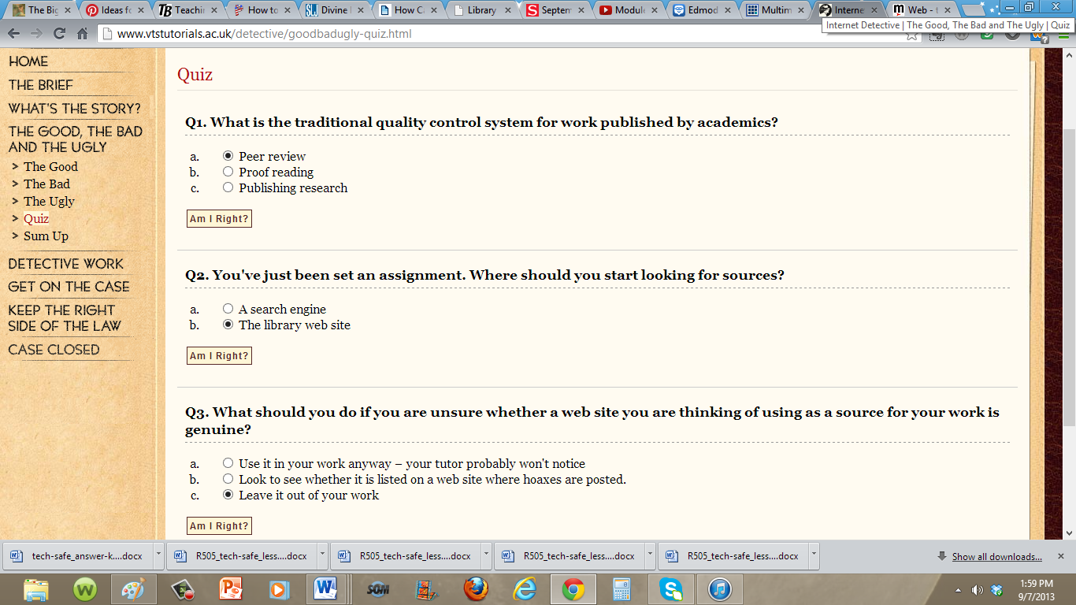

Copyright & Fair Use in Education
ACTIVITY:
- Take Edmodo quiz on copyright.
- Use the following links to find the answers to the quiz.
  - Click for information on copyright in education
  - http://www.halldavidson.net/copyright_chart.pdf

COPYRIGHT FOR YOUR STUDENTS
- GO through http://digitalpassport.orgCreative Credit: Mix n Mash to learn ways to teach copyright to younger students.
- Use articles to further students understanding.
DISCUSSION ACTIVITY:
- Prompt: What techniques could you use to teach your students about copyright laws?
  - Respond here & paste in Edmodo Module 2 discussion post.
    - Follow the rubric for discussion posts.
  - Reply to one other student using techniques learned in module 1.
CREATIVE COMMONS
ACTIVITY:
- Find a picture you have taken or take a new picture
- Go to the creative commons website.
- Fill out the information in each box
- Copy the license and paste below as show in the example.

Insert a Picture that you have taken HERE  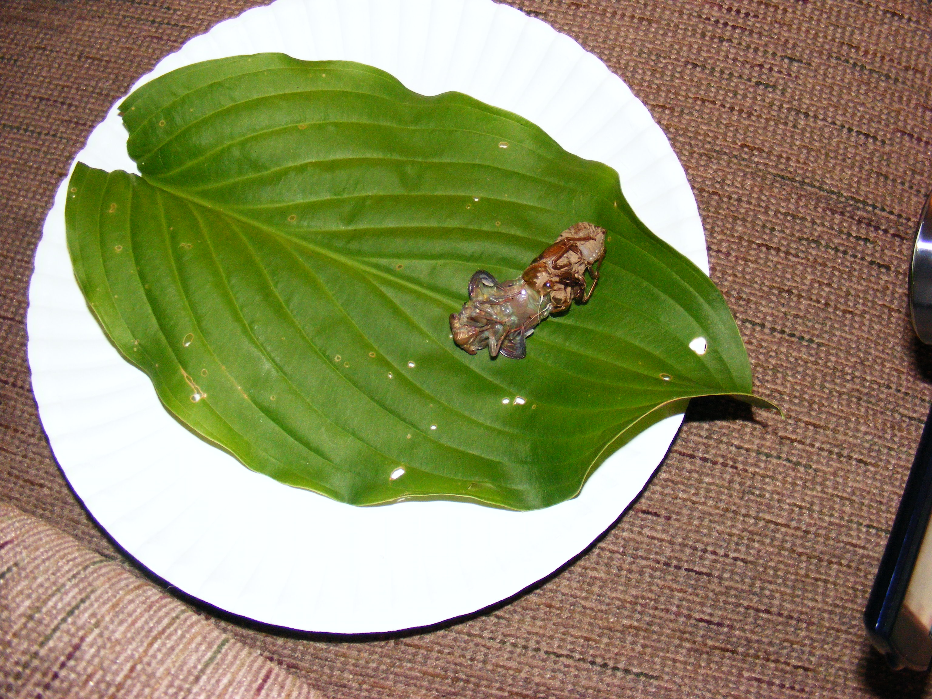 | Copy your creative commons license here.  Cicada Emerging by S Jones is licensed under a Creative Commons Attribution-ShareAlike 3.0 United States License.
Sample Image | Sample License  Ice Cream Cake by Kelly Bratcher is licensed under a Creative Commons Attribution 3.0 United States License.

ACTIVITY:
- Find other images online that you are free to use.
http://search.creativecommons.org/ | http://compfight.com/ | http://www.zoo-m.com/flickr-storm/ | http://www.flickr.com/creativecommons/
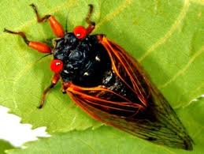 | 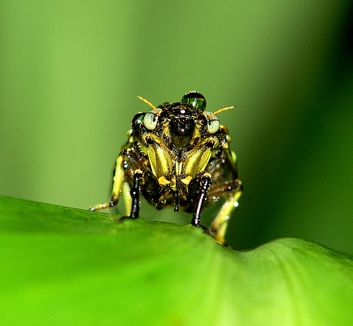 | 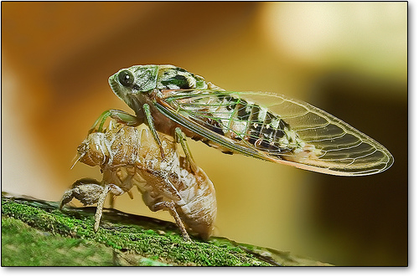 | 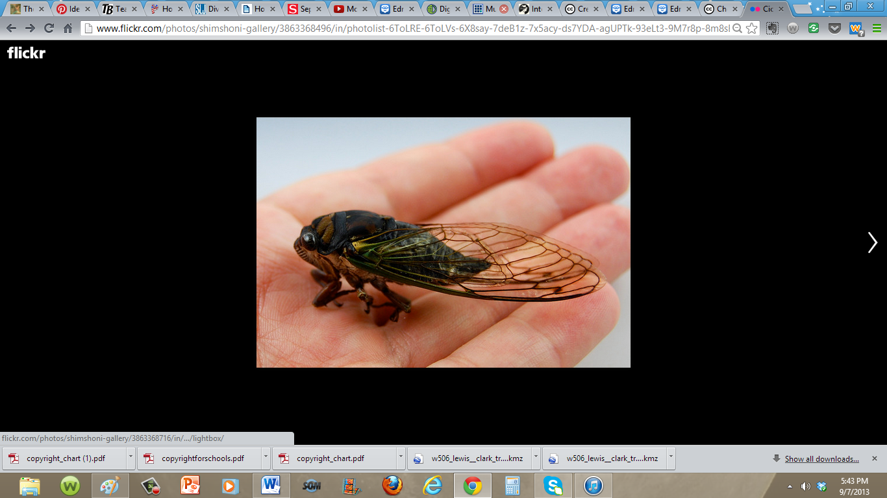
Original content on this site is licensed under a Creative Commons Attribution-ShareAlike 3.0 Unported License. | Photo Credit: <a href="http://www.flickr.com/photos/76195812@N00/555009437/">Matthew Fang</a> via <a href="http://compfight.com">Compfight</a> <a href="http://creativecommons.org/licenses/by-nc-nd/2.0/">cc</a> | by Fernando Felix (contact) | Elena Samsonova_shimshoniMember since 2006  - Taken on August 27, 2009  - Nikon D40X  - 1,377 Views  - Photo list (51)  - cicada  Additional info (show more)  - All Rights Reserved

